Blog Page Update
- Delete Function is not working.
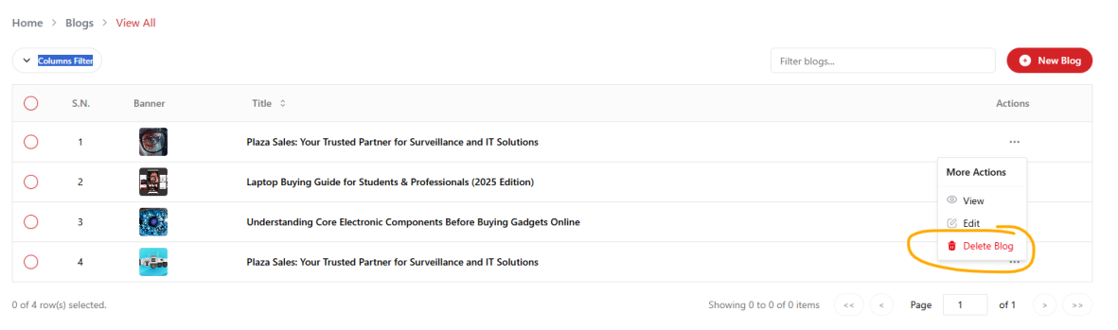
- Not displays more then 3 blogs in blog list page.

- Blog Detail Page:
  - No need of reading times and author
  - Bold fonts looks hazy. Please confirm.
- Detail delete function not working.
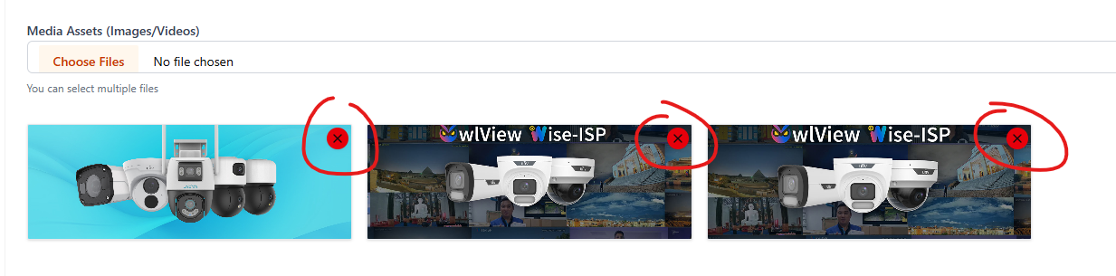
- Remove Detail page image Border and background.


